October Puzzling Phenomenon: Which is faster?
Developed by John Gensic, September 2016

Title: Which is faster? Straight vs. Curved Downward Paths

Concept: Energy transfers, (potentially forces and motion)

Introduction and Phenomenon:
On a recent family outing to the Kalamazoo Valley Museum, my son and I were playing at the science level where we found this puzzling phenomenon. Two disks are placed on two separate paths, one is on a straight slope, the other’s path is curving up and down to the end. The straight slope is about 6 inches shorter than the slope with lots of little hills.
Same starting points

Same ending points
The curved path is about 100 inches.
The straight path is about 94 inches.
Which path takes longer for the disk to travel?
Watch Youtube video here: https://www.youtube.com/watch?v=Tpkq_GYIxRk

The disks are identical and have the same starting height. I suggest you stop the video at 20 seconds into the video, before the disks are let go. I’ve always been told that the shortest path between two points is a straight line. However, this phenomenon seemed to contradict this rule of thumb. But why?

Explanation of the science involved:
From the Kalamazoo Valley Museum exhibit…
“The experiment shows how energy can be converted from one form to another. The disk on the wavy track converts potential energy into kinetic energy at a faster rate, allowing it to reach the end first.
Before the disks are released, they have potential energy. They may be sitting still, but they have the potential to do something, such as fall. Once they begin rolling down the track, their potential energy is converted into kinetic energy. Kinetic energy is the energy of motion.
On the straight track, the conversion of potential energy to kinetic energy occurs at a constant rate.
On the wavy track, potential energy is converted more quickly into kinetic energy on the first steep drop. However, as the disk travels up the first hump, some of the kinetic energy is changed back to potential energy, slowing the disk down. When it travels downward again, the potential energy is converted back into kinetic energy. 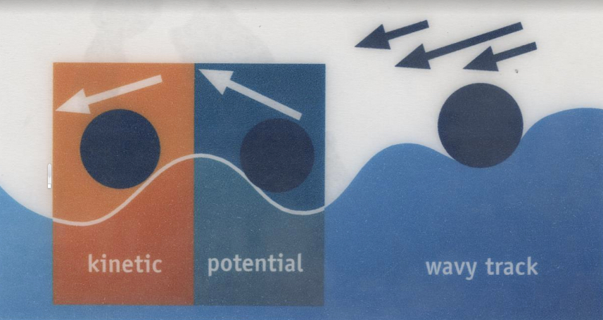
Both disks start the race with the same amount of potential energy. The disk on the wavy track accelerates quickly, changing its potential energy into kinetic energy faster, allowing it to win the race even though its descent is interrupted by the humps, and its path is 6 inches longer than the straight track.

A roller coaster converts potential energy to kinetic energy as it dips, twists, rolls, and zips through the ride. Did you know that after the first hill, no motors, cables, or chains are needed to move the car along the track? (However, many roller coasters do use chains to boost the ride.)”

Further ideas for classroom use:
Could be used at the start of a unit on energy. By pausing at 20 seconds into the video, this can be an opportunity to elicit student ideas and language around this phenomenon.
When pausing at 20 seconds into the video (potential questions):
-What do you think is going to happen? Why?
-Who agrees with _______ about their prediction? Why?
-What other ideas are out there about what is going to happen?
-Who thinks it will end in a tie? Why? Why not?
-Have you ever seen this before? Where? How does that relate? Does that impact your prediction?

After watching the entire video (potential questions)…
-What happened? What did you notice?
-Compare what happened with your initial ideas. How would you revise your initial ideas?
-If the tracks were much much longer, would the straight line path eventually catch up?
-Have you ever seen a situation like this before? Where? How is it similar or different to this situation?

Engineering connections:
-How do the results of this situation apply to designing roads vs. roller coasters?
-How is this situation similar or different from a curving road vs. a straight road on a flat surface?
-What are switchbacks? Why are they used?

Modeling Connection:
-Students could also draw explanatory models before the video of what they think is going to happen. They could then revise their initial model of the situation after watching the rest of the video. They could also revise their model of this situation later in a unit on energy transfers or forces and motion.

