eLearning Ideas for AP Chemistry
Kevin Morse: Westfield High School
morsek@wws.k12.in.us
- Keep Calm
  - August - March happened
  - College will come
  - Be open & honest with the kids
  - Set realistic goals for each day & get regular feedback from the kids

- College Board: https://apcentral.collegeboard.org/about-ap/news-changes/coronavirus-update
  - Free, live AP Review courses starting 3/25 (Not yet linked)... Also recorded
  - Tips: https://apcentral.collegeboard.org/pdf/ap-program-coronavirus-covid19-release.pdf
  - Exam:
    - 45-minute online exam at home: flexible devices (devices available based on need)
    - 2 test windows, dates TBD (Sooner for those who are ready, later for those who need to review)
    - Details of testing windows ready by 4/3
    - Cancel at no charge (if needed)
    - Colleges still giving credit
    - Covers Units 1-7, NOT 8-9
      - Atomic Structure & Properties
      - Compound Structure & Properties
      - Intermolecular Forces & Properties
      - Chemical Reactions
      - Kinetics
      - Thermodynamics
      - Equilibrium
      - Acids & Bases
      - Applications of Thermodynamics (Electrochem)

- AP Classroom: Take the tour if you haven’t used it... More stuff now than before
  - PPC (Personal Progress Checks): All 9 Units, MC & FR

  - Question Bank
    - Sortable SO MANY WAYS!!!
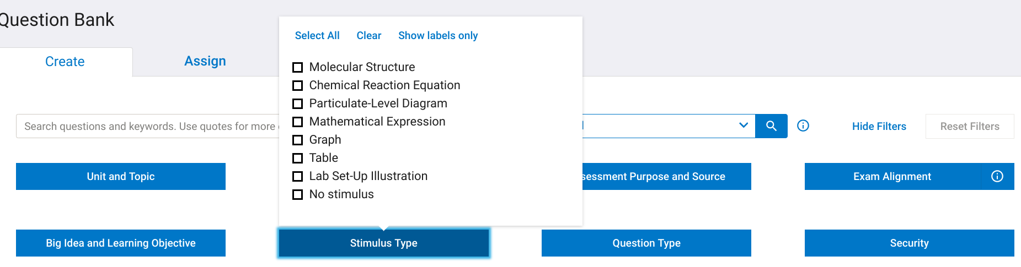
- Recording videos
  - Screencastify: https://www.screencastify.com/ (Coupon = CAST_COVID)

  - EdPuzzle: https://support.edpuzzle.com/hc/en-us/articles/360039805612?fbclid=IwAR3H6iB89jMPTlP0CZ6uxltDGMlKTKQAGZM_eXaaM8SGF9atHrpMQRvTB4Q&ck_subscriber_id=113738579

  - DOZENS of others for all operating systems, look at reviews, ask for premium trial

- Interactive conferences
  - Lots of free options depending on needs

  - See if it’s built in to you LMS (Canvas Conference, Blackboard Collaborate, etc)
    - Discussion boards: Keep the kids talking to each other!
    - Have kids turn in work & post it to share

- Virtual labs
  - YouTube process & provide data: https://www.youtube.com/results?search_query=ap+chemistry+experiments

  - DIY & time lapse it: https://drive.google.com/open?id=1joglo95Vt2l7ktHhmM8g7N47x5OOiqHj

  - PhET: https://phet.colorado.edu/en/simulations/category/chemistry

  - University of Oregon Demos: https://chemdemos.uoregon.edu/

  - ChemCollective: http://chemcollective.org/home

  - ACS Virtual Chemistry: https://www.acs.org/content/acs/en/education/students/highschool/chemistryclubs/activities/simulations.html

  - Free stuff from your normal vendors? Doesn’t hurt to ask!
    - Vernier:https://www.vernier.com/remote-learning/?utm_campaign=remote-learning-solution
    - Flinn:https://www.flinnsci.com/athomescience/?utm_campaign=MKT20383%20-%20Mar20-DistanceLearning-President-Email&utm_medium=email&utm_source=Net-Results&utm_content=MKT20383%20-%20Mar20-DistanceLearning-President-Email#s&utm_source=house-file&utm_medium=&utm_content=

  - The internet is amazing!!!
    - https://edu.rsc.org/resources/titration-screen-experiment/2077.article
    - http://glencoe.mheducation.com/olcweb/cgi/pluginpop.cgi?it=swf::800::600::/sites/dl/free/0035715985/117354/Equil_Nav.swf::Equilibrium%20Simulation
    - http://www.learncheme.com/simulations/thermodynamics/thermo-1
    - https://www.playmadagames.com/subscribe/?utm_source=newsletter&utm_medium=email&utm_campaign=reminder_2

- Still need to deliver content?
  - Khan Academy: https://www.khanacademy.org/science/chemistry/ap-chemistry
    - Create class, assign content
  - ThinkWell: https://www.thinkwellhomeschool.com/collections/ap-courses
    - Email sales for free access: sales@thinkwell.com

- Exam Review
  - Simplify: Review ≠ Teaching
    - 3-6 “big ideas” to remember, help manage & prioritize
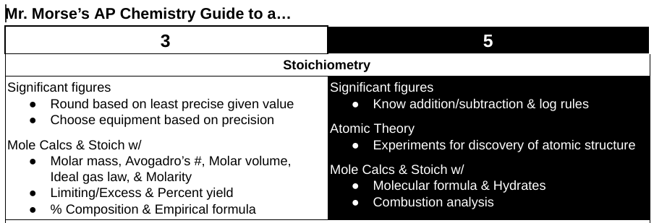
  - Let them choose their path
    - Certain “key” check-ins (required content) w/ options
    - Use the data from August-March to help guide/nudge them the right way

  - Use released exams: https://apcentral.collegeboard.org/courses/ap-chemistry/exam/past-exam-questions
    - Questions & scoring guidelines
    - Sample responses

  - Review books ($10-25 on Amazon)
    - Crash course vs. Practice questions

- Creative tools to keep them interested
  - Deck.Toys: https://deck.toys/coronavirus-support

  - GimKit: https://blog.gimkit.com/blog/support-for-educators-impacted-by-covid-19

- Tools for you
  - AP Discussion Board: We’re all in this together

  - Adrian Dingle: https://www.adriandingleschemistrypages.com/
    - Blog w/ tips
    - Free COVID web conferences for students

